

Manual ver 1.02

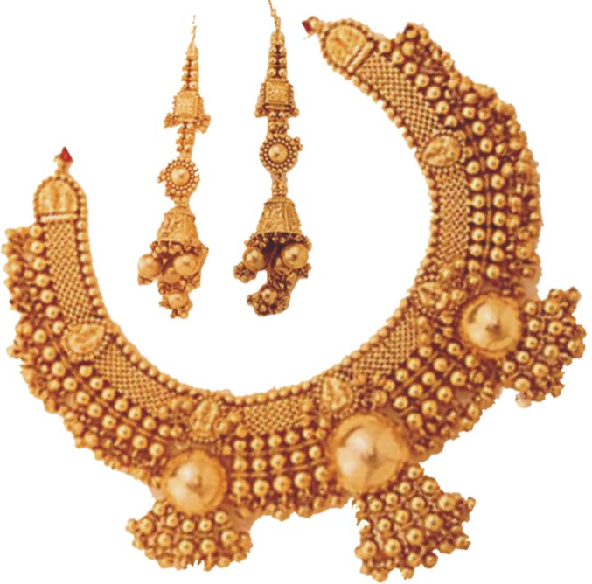

Showman Gold X with automatic GST entries is
FREE with one box of Jeweltag
for Limited period and limited Copies only
1. Will work for One company only (one GSTN)
2. Lan version : upto 3 user free ( for 5 users = (add) 10000/-)
3. Updates for 1 Financial Year guaranteed
4. Free Support only on forum as possible by us
- Forum address http://meganet.co.in/support
5. Online support via internet Rs. 5000
- Max 5 sessions with 1 session of 1hr per day
- subject to availability of training slots – with prior appointment on email or forum)
6. Voucher Print Settings are fixed for the free versioin –
- you can request changes or report bugs on the forum

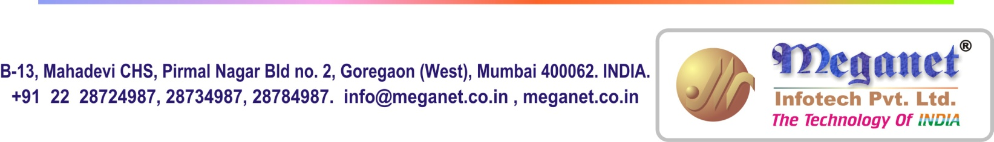
Changes:
08/08/17:
Payment, MPayment Changed name of DesignNo Column to Chq. No
Payment, Mpayment Chqno shows last chqno +1

This manual is being Updated ……

SHOWMAN-GOLD X MANUAL

This manual is a step by step guide to get you started instantly with the showman gold X package. It does not cover all the aspects, only the essentials

Installation
Showman Gold X Requires Installation in to your system. To download the installation file go to
Meganet.co.in >>>> Downloads And Updates >>>> Full Version (of Showman Gold X ) your browser should download sgxsetup.exe. run this file
Setup will ask for the path for installation. If you are unsure leave it as the default c:\sgoldx Press Next the software will be installed and icons will be created on your desktop
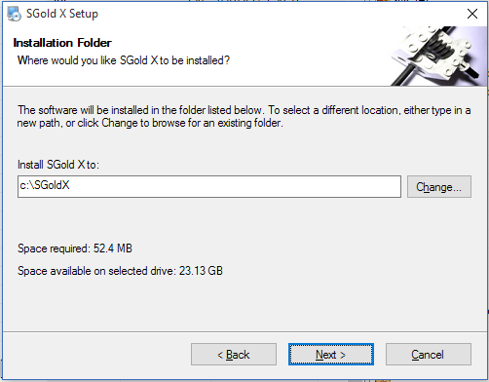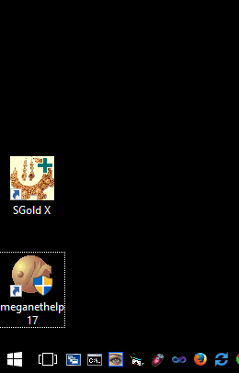

Running SGold X will present you with a file Open dialog box. Every company in Showman Gold X is a file and all the data relating to that company is contained in that file. This makes securing and moving data very easy. There is already a file contained with the setup called GSTSampleData.SGX. sgx is the extension that Showman Gold X uses for the data files. You can select this file and open it and check for entries and test entries etc. or you can create a new file from the File New menu. Selecting the file to open will show you a login screen the default Username is – s there is no password for s (blank password)
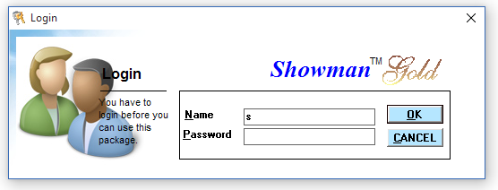
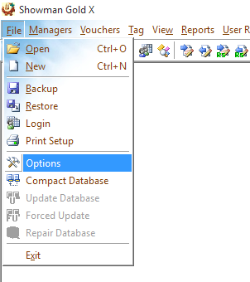
All information relating to the company is in the File Options. The name of company, address, the financial year, GST details etc

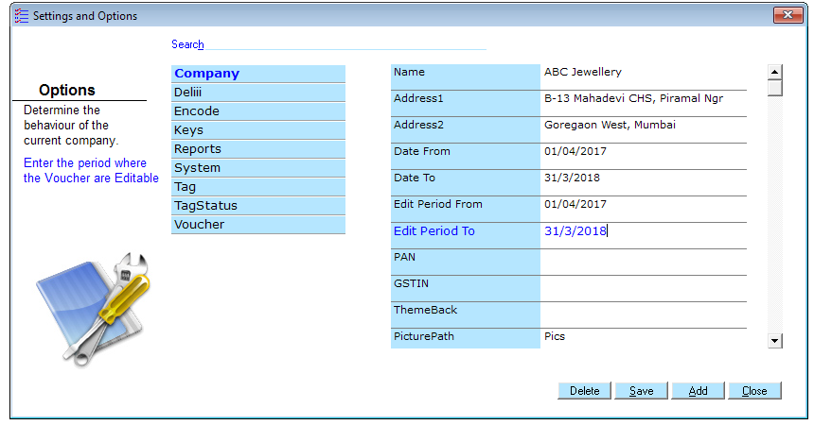

You can change this detail at any time
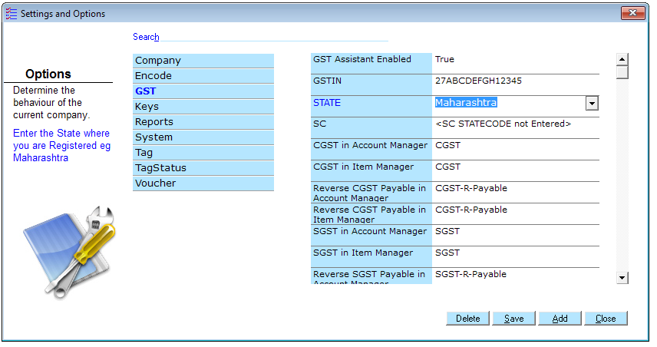

You must once check the GST details and fill them becaue these details are required for SGold X to make and manage your GST Entries
GSTin = your 15 digit GST number exactly
State = where your GST is registered
SC = is statecode in numeric eg 27 for Maharashtra
GSTin,State and SC (State Code) are important and should be filled in

All other entries do not need to be changed
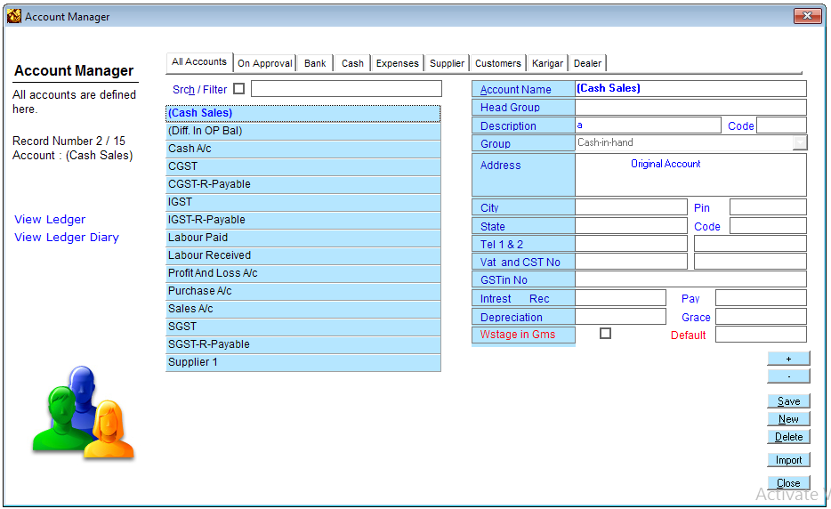

Account Manager
All accounts are created in the Account Manager click on Managers > Account Manager to accesss the account manager

For eg to create a new karigar account

Click on Karigar Click on New
Enter name of Karigar Press Enter to move to another field Press Enter continuously till the name appears in the list
Press Save
A 15 digit GSTin number is required if the party is a GST Registered
In this way you can create all accounts for karigars , customers, expxenses, banks, cash, capital etc.
State Code of the Party if the party is GST Registered

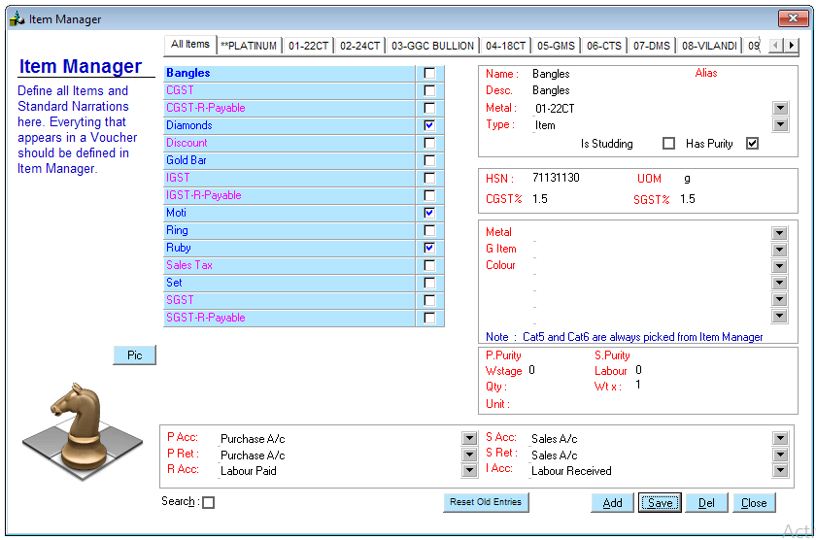
Item Manager
All Items are created in the Item Manager click on Managers > Item Manager to accesss the item manager

For eg to create a new Item
Click on New
Enter name of Item Press Enter to move to another field Press Enter continuously till the name appears in the list
GST Details for the Item most Jewellery items attract 3% GST
1.5 for CGST,
1.5 for SGST
Press Save

Vouchers

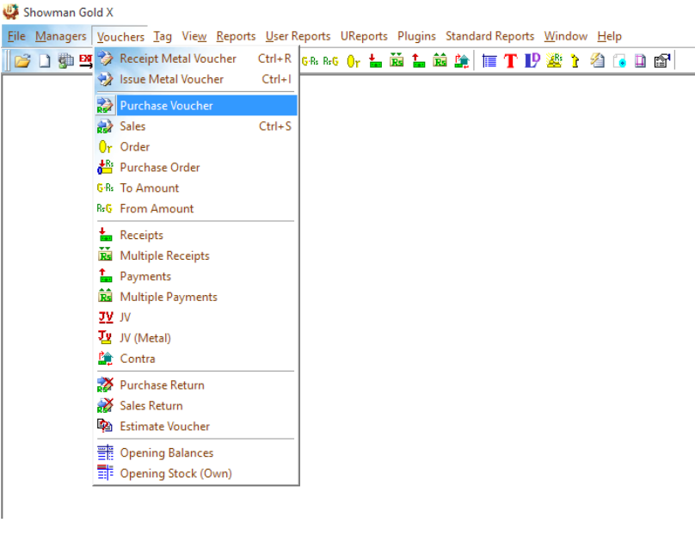
Vouchers are the basis of all entries in Showman Gold. Remember that there are four 4 vouchers that affect stock.
For Inwards Purchase and Receipt
For Outwards Sale and Issue

There is only one difference between purchase and receipt. What ever you purchase will be paid in Rs. While what ever you Receive will be posted as credit and will be payed back in same material eg gold against gold.

Eg if you purchase 100 gms of gold ornaments at the rate of Rs 800 and the Amount is showing Rs 80000 the party account will be credited by Rs. 80000

Eg if you do the same entry as Receipt that is 100 gms of gold ornaments the package will not post the amount of Rs 80000 to the party account but will credit the party by the gold received that 100gms

Please note however the LAmount (that is the labour) is always posted to the account so even during the above Receipt if you enter Rs 10000/- in the LAmount this amount is posted to the Party Account as credit.

Similarly

There is only one difference between sale and issue. What ever you make a Sale of you will receive payment in Rs. While what ever you issue will be debited to the party account in the same material Gold, Diamonds, etc.

Eg if you make a sale of 100 gms of gold ornaments at the rate of 850 and the amount is showing Rs. 85000 the party account will be debit by Rs 85000

Eg. If you do the same entry as Issue that is 100 gms of gold ornaments the package will not post the amount of Rs 85000 to the party account but will debit the party by the gold issued that is 100gms

Please note however the LAmount (that is the labour) is always posted to the account so even during the above Issue if you enter Rs 15000/- in the LAmount this amount is posted to the Party Account as debit.

Just follow one golden rule of thumb.

Make entries as they happen and automatically everything will be posted to the accounts and inventory.

Eg. If you issue 100 gms gold to a karigar (Vasant) there is no need to calculate weight after alloying. What you have physically done is given 100gm pure gold bar to Vasant. That is exactly what you should enter. Make issue voucher of 100 gms gold of 100 % purity in the name of Vasant. Now if you receive 50 gms of ornaments of 75% purity Showman gold will automatically do the calculations and show that 100 x 1.00 – 50 x .75=62.6gms of gold is pending with Vasant. You will understand this as you read the following.

To understand we will consider all sample entries as plain gold jewellery. Showman Gold works with any number of studdings, Diamonds, Kundan etc…. later we will consider one entry with studding and it will be clear that the concept is very simply, the same.

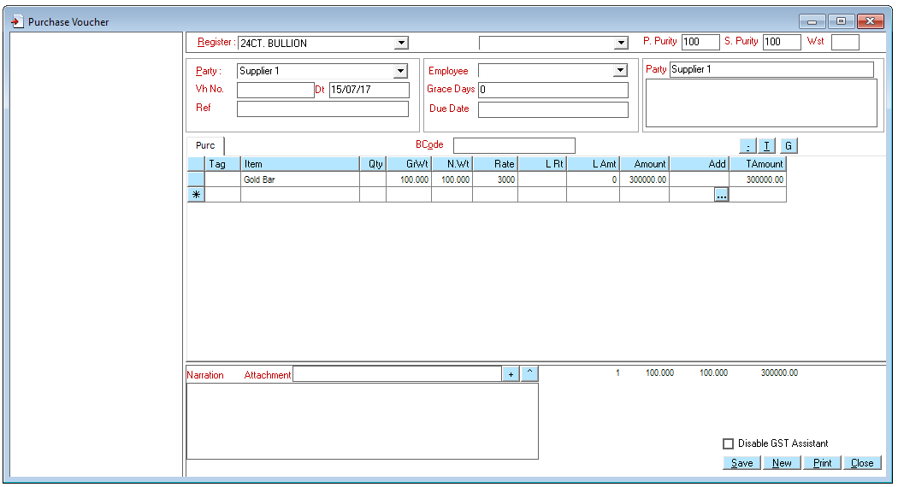
Purchase
First we will purchase 100 grams of Gold Bar from Supplier 1.

Do the following
Select Voucher – Purchase Voucher. You will Get a Blank Purchase Voucher

Enter data so that Your screen looks like this
Purity of items in this voucher. You can put 99.5 or 99.9 if required
Press SAVE

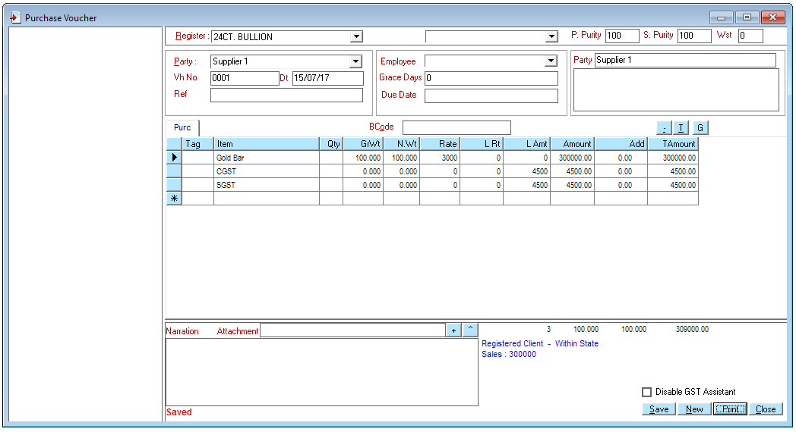
You will observe that Showman Gold has added two lines CGST and SGST with the relevant amounts to the voucher

And at the bottom it says in blue that the party is a Registered party and the party is from within your State ( the state code in Account Manager for this party matches SC of your own GST setting in Options. If no state code is mentioned in the party manager party is assumed to be local)

If it was a different state Showman Gold would have added IGST instead of CGST and SGST.
You can print this voucher if you want the entry is saved

Example of entry with party which is within State 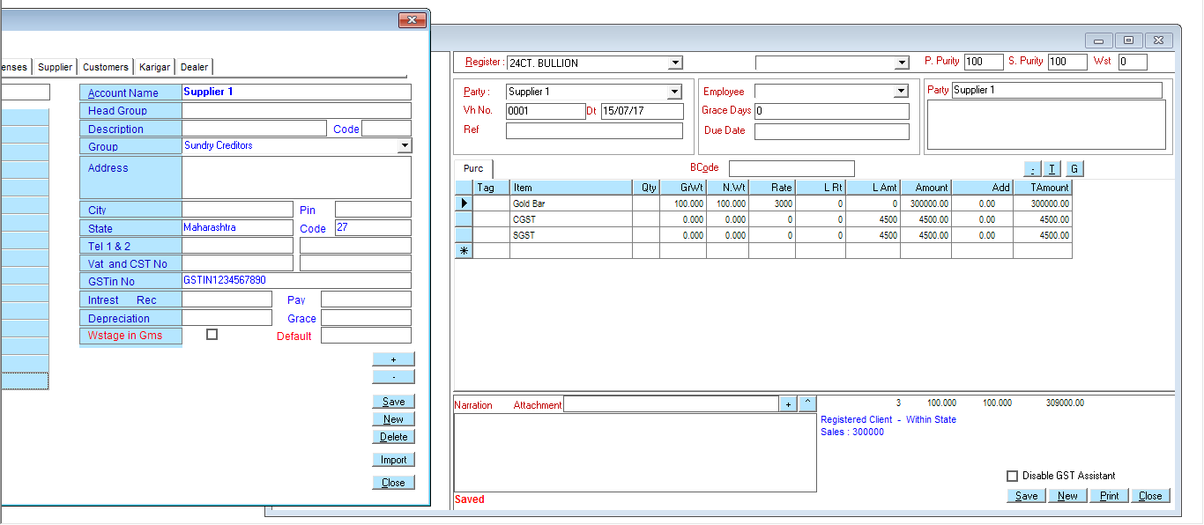
Example of entry with party which is within State
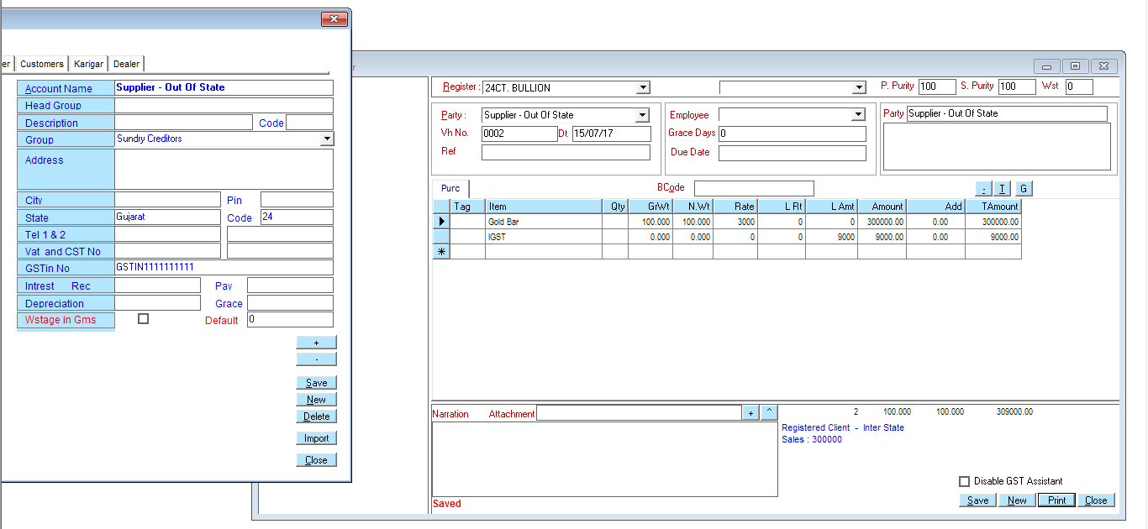

You can view (and edit …) old voucher entries made by you by selecting View Voucher
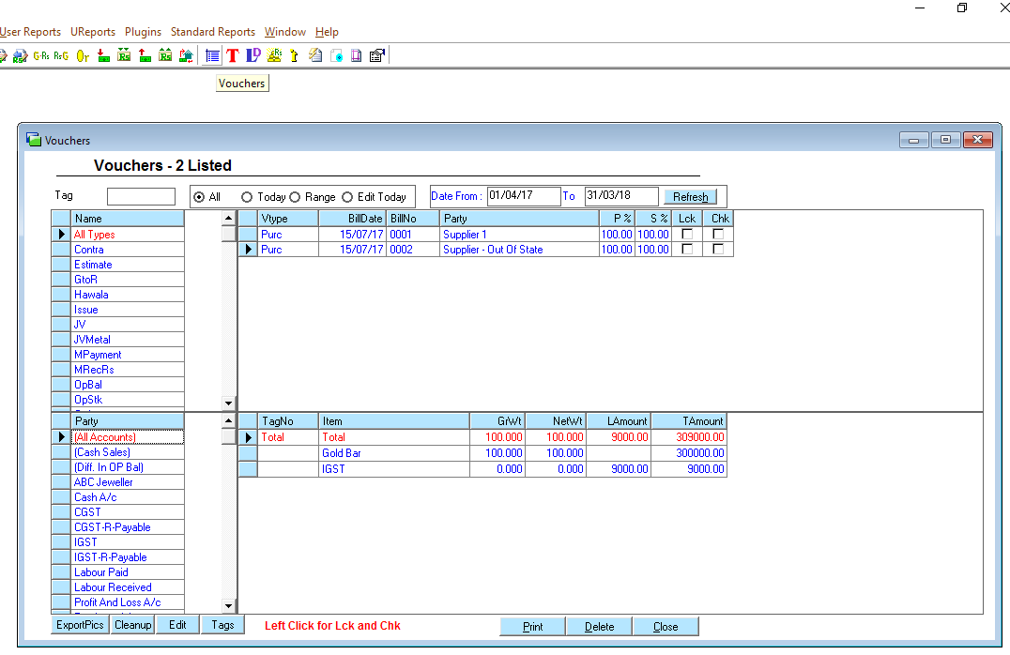
Double Click here to open / Edit this voucher
Select View Voucher Icon to Open the Vouchers Window shown below

Now let us look at the effects of the above Purchase vouchers on Stock Accounts
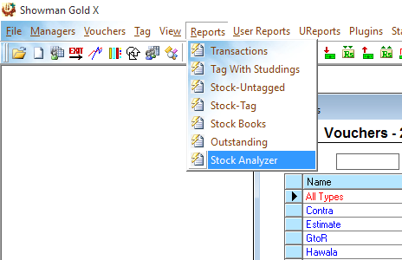
To see the current stock select Reports and Stock Analyzer
To see the current Stock

A report showing the current stock will open. This is an analysis report and you can modify and view this report with many details

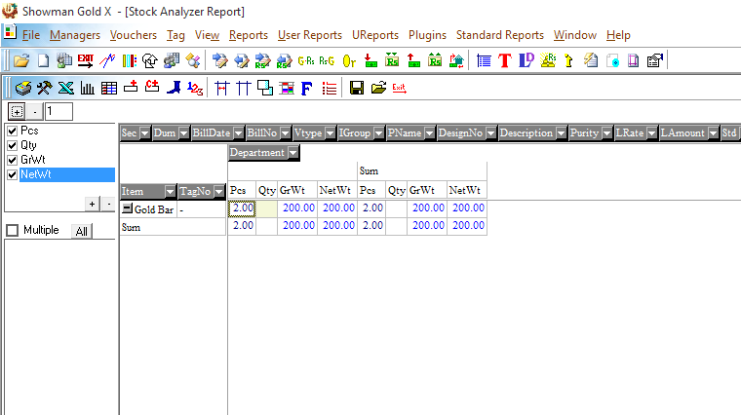

Click here to see how this report can be modified according to your taste

Trial balance

Issue Voucher.
As we have seen we have 200 gms total of gold bar. Let us issue 150gms to Swapnesh, who is our karigar

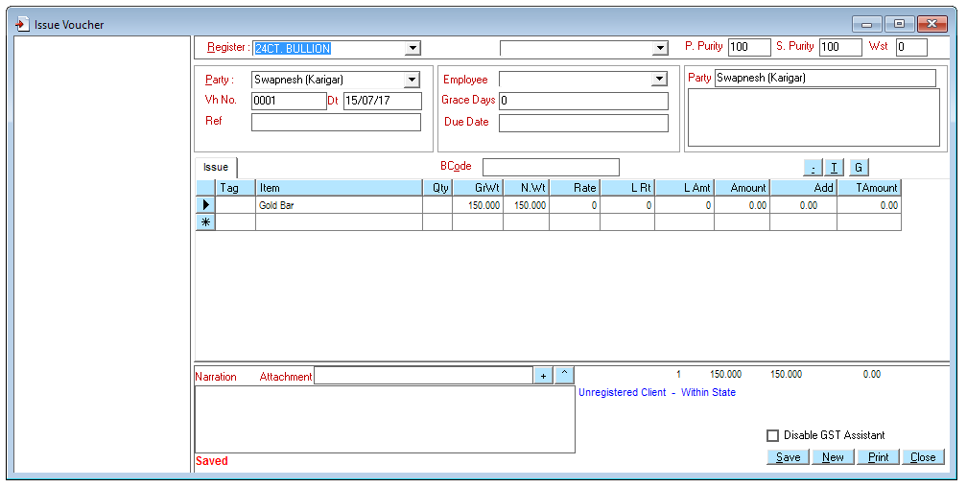
Point to note is that this voucher does not affect our Rs. Account the Karigar Swapnesh’s account is debited by 150gms X 100% that is 150gms of fine gold. Had we had put something in the Rate and amount column this value would not have affected the karigar’s account. However if we put something in the LAmount column eg Rs. 1000 this will definitely be debited to the karigar’s account. So this transaction should have two effects
Our stock of gold bar should decrease by 150 gms and the karigar should be debited by 150 gms of gold

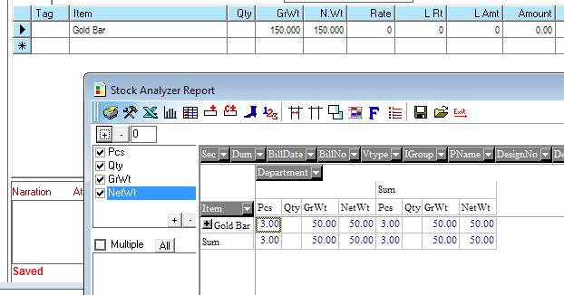
View Stock from Reports > Stock Analyzer and
the karigars Account from View > Ledger Diary

Receipt Voucher.
Now let us assume that the karigar Swapnesh makes a ring and gives it to us which is 25gms at 91.6% purity and charges 200 Rs. Per gm Labour. Let us make the entry as shown below
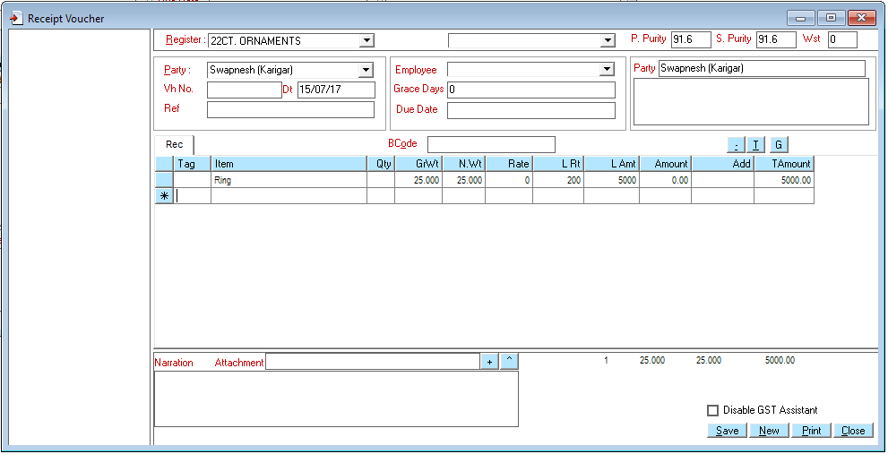
As soon as we save the voucher we observe that Showman Gold has added the entries for Reverse CGST and SGST because it is a job work the CGST and SGST are updated at total 5% (2.5% CGST and 2.5% SGST)

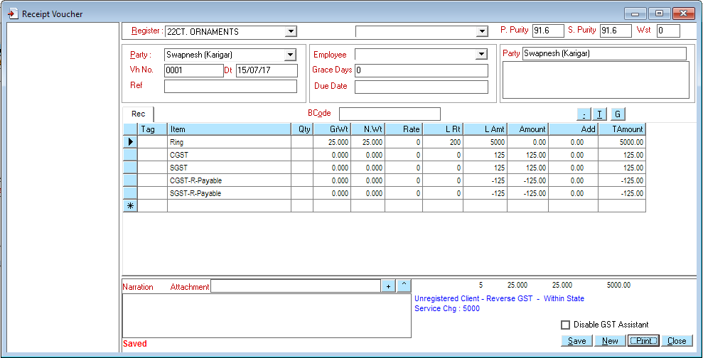
GST Assistant explains what transaction was done in this voucher with ref to GST
These four lines are automaticall added by Showman Gold. And calculated at 5% because this is a Job work

In short Showman Gold is smart enough and you do not have to worry about GST
Just like Issue Don’t worry about the rate. Rate and amount are not posted to Vasant’s account.

Again this voucher has an effect on our stock and also on the karigar’s account other then the effect it has on GST Account (the effect on the GST accounts is simple enough and we will see that later in detail)
Let us observe what the Stock Analyzer now displays
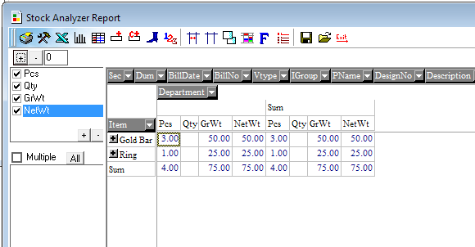
The ring of 25 gms is now in stock
Note the purity of Gold bar is 100% and that of ring is 91.6 … we could have seen this if we bring down the purity field in place of department

Now let us see the karigar’s account
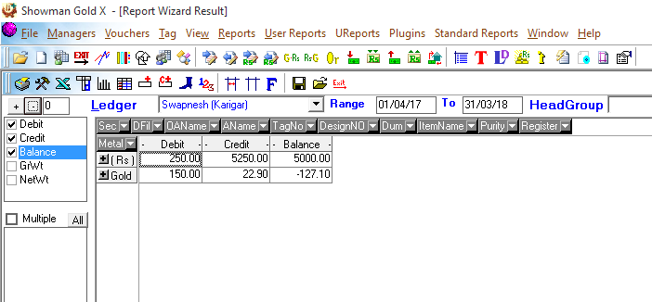
Total amount payable to Swapnesh is only 5000,
The amount of Reverse GST cancels with GST for the Karigar Because he is unregistered we pay the amount
22.9 is fine
because 25 gms is of 91.6% purity
2. Enter Karigar’s name to view his Account
1 Start Ledger Diary from here

We see that everything has been updated to his account we gave him 150 gms gold which was fine. He gave us a ring which was 25 gms at 91.6% purity which means 22.9 gms fine so his account says he has to pay us 127.1 gms of gold ( the minus means we need to get it from him)

The total amount payable to him as labour is 5000 which we input in the voucher. Because the karigar is Unregistered we must make a Reverse GST which is automatically done by Showman Gold.

So what if it was a GST registered Karigar lets quickly see an example (if you have filled in a 15 digit GST number in the Account manager for a party it means the party is GST registered)
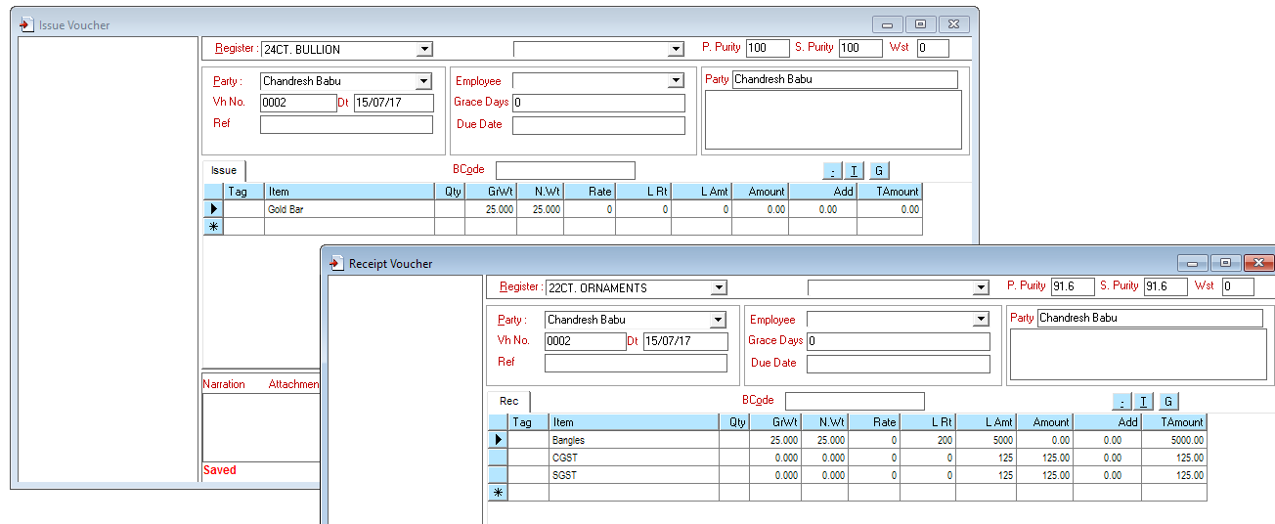
Note we do not need to enter the two lines of CGST SGST or IGST

Showman gold will automatically add these lines
Observer that showman gold now adds normal GST entries as reverse GST is not applicable

We have to pay him 5000 + 250 for gst and he will pay the GST because he is registered we will get 250 GST credit
The above entry has CGST and SGST because the karigar is within our state if we change the state code of the karigar to another state and save this same entry again Showman Gold changes the entry to as shown below

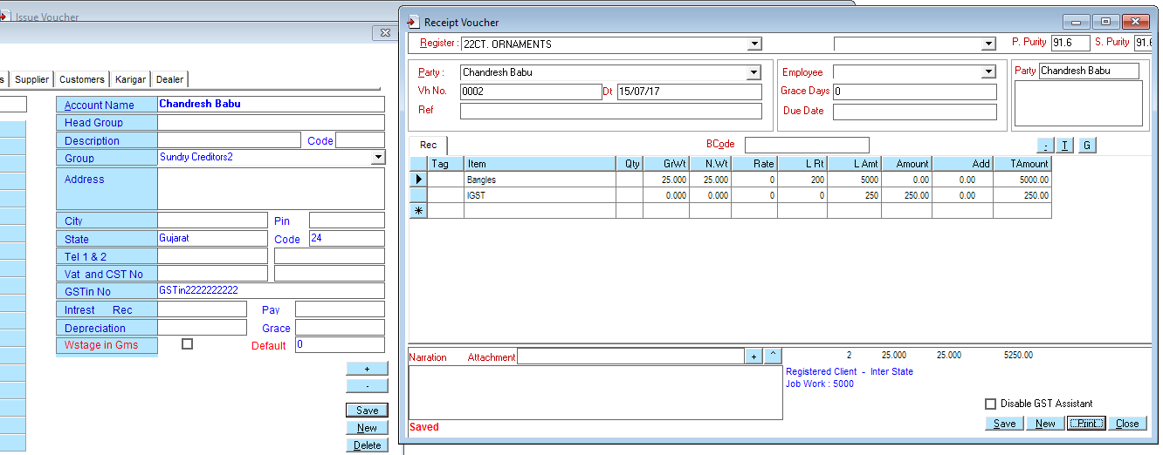
This is the same voucher when we save it now Showman Gold Removes the two lines for CGST and SGST and adds IGST
Account Manager State Code changed to 24 so he is now in another state
(Demo SC=27)

The Concept of TAGS
In a jewellery concern when a piece of jewellery is received, the piece is further issued to another karigar either for having further work done on it, or for some process like polishing or Rhodium or Hallmarking etc. If the item we received was a finished item it would be sold. In all cases every piece of jewellery is unique in terms of weight, purity, design, size and also because it may contain stones, kundan, diamonds etc studded. We already do the entry about the weight, stones etc when doing a receipt and we should not have to do the same entries when doing either an issue or a sale with it. So we add the concept of Tag. We put a lable on the piece of jewellery when we receive it and give it a number. So when we issue or further process this jewellery we can enter this tag number so that we do not have to remember the weight design, stones etc for this jewellery

So while receiving a piece of jewellery if we put “+” in the tag column showman gold generates a tag number for this piece and we can use this tag number to issue this piece to someone else

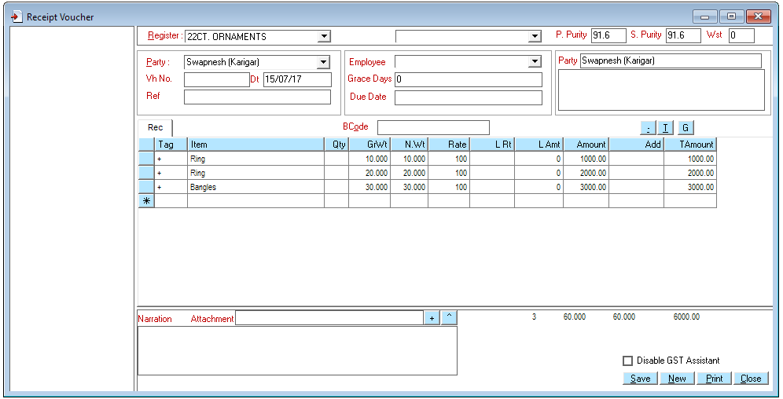
+ in tag column means we want the system to generate a tag for these ornaments .

The above screenshot is before we saved the voucher. As soon as we save the voucher, we see that the system has changed the Tagno column to +1,+2,+3 the first item has the tag number 1, the second has the tag number 2 etc. the system assigns the lowest number which is not in stock. So if we already have tag numbers 1, 2, 3, 4, 6, 7, 9 in stock the system would have given the numbers 5, 8, and 10. In any case we do not have to worry about the numbering as showman gold automatically gives the lowest available number

We can check the Stock Analyzer and if we expand using the + button we observe that tags 1, 2, and 3 are indeed in stock.

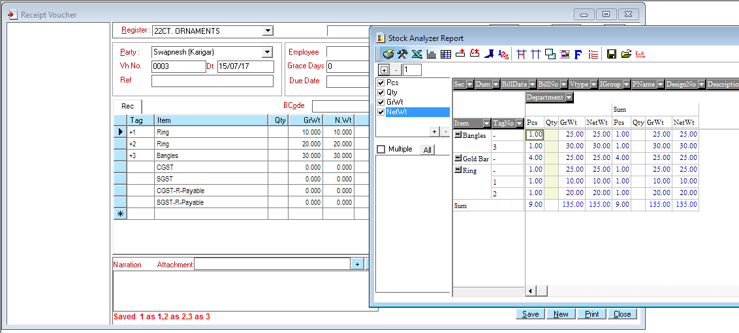
Saving Created these tags.
This will expand the report and will show more details if it is available in the report

Sales

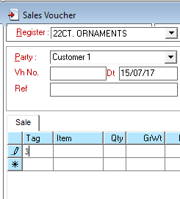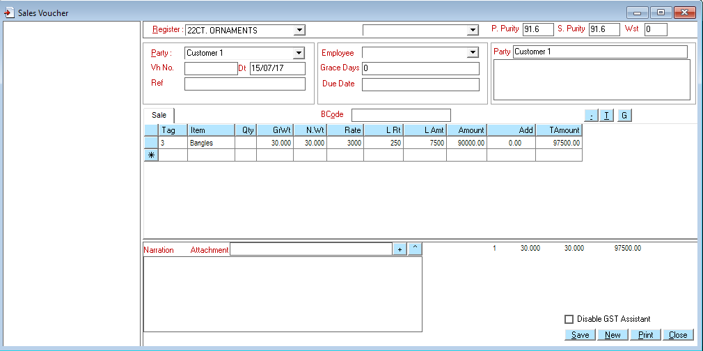

Now let us try to make a sale using the above generated tag. For eg we can enter the tag number 3 in the Tag column and the system will fill the details of the tag its weight etc. we can then change the rate and LRt or LAmount and save this voucher. This tag will be removed from stock because it will be marked as sold

Once it is saved we can print the sales bill by pressing Print button we

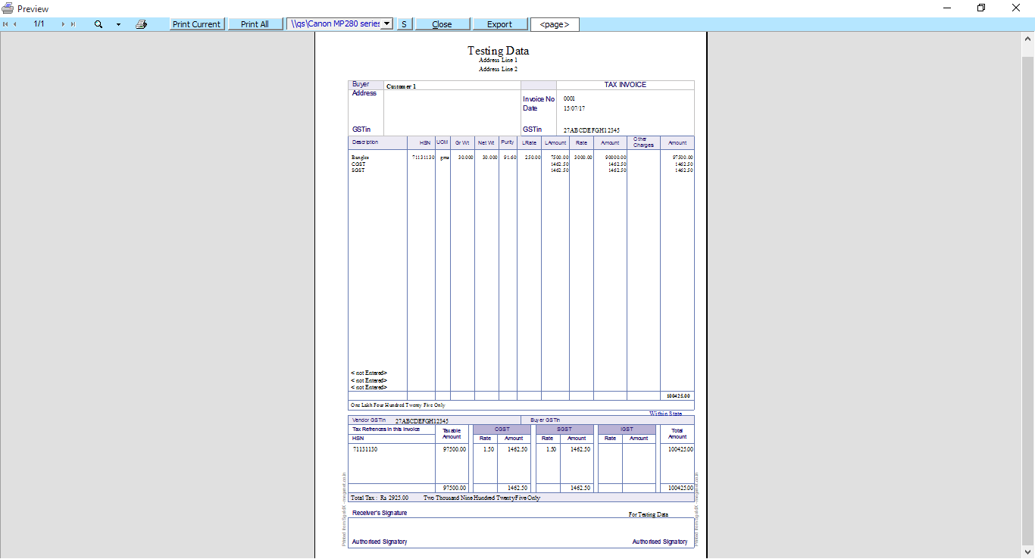
Press the “Print Current” page to the default printer. Or Press “Export” to export the print preview to a pdf file

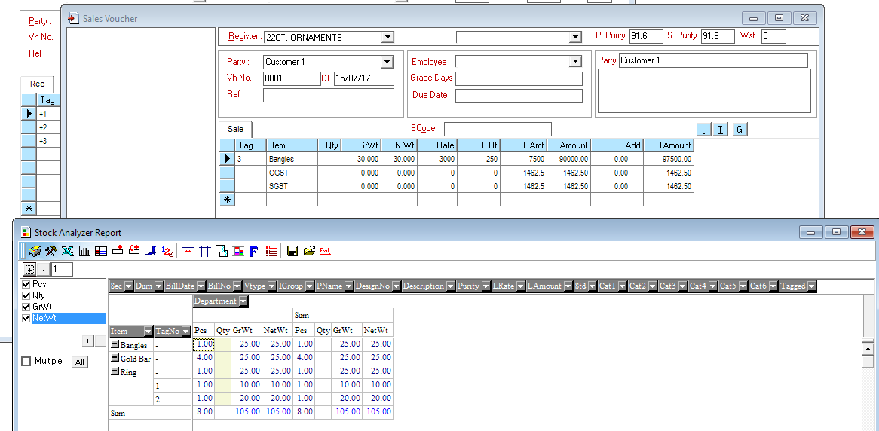
As soon as the sale is saved the tag number goes out of stock and is no longer seen in the Stock Analyzer

We can observe the effect of this sales ( of any entry ) in the Trial Balance [View >> Trial Balance ]
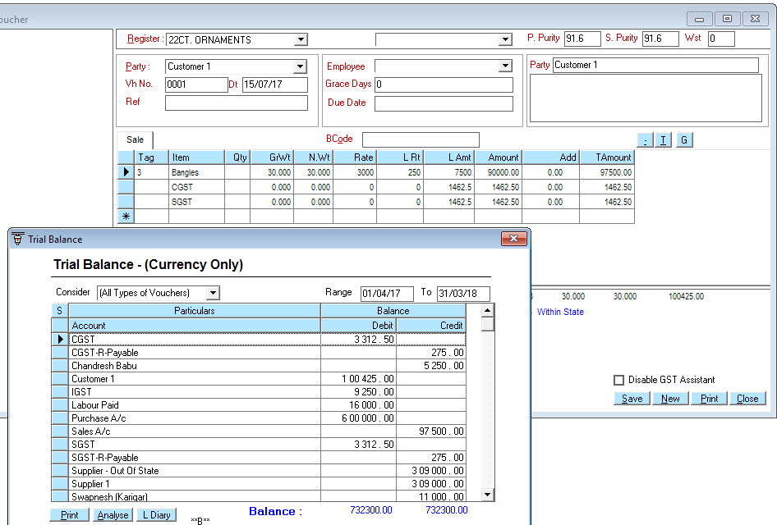
Customer 1 debited by the bill amount
Payment can be received by Receipt Rs voucher
CGST, SGST, Sales and other accounts have been appropriately updated

We can Receive payment for the voucher by selecting Vouchers >> Receipt Rs for eg.
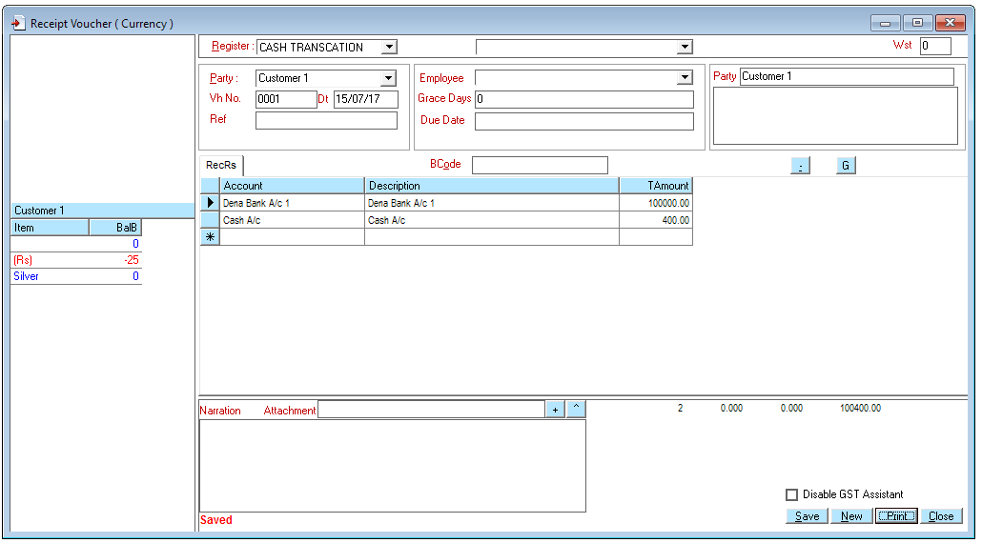
Party balance is available if “ShowPartyBalance in Voucher” is set to True in Options >>> System

We have completed a simple cycle of trade for the jewellery business …. There are other considerations eg studdings, tag printing etc… this manual is being updated ….. pls have patience

The latest manual can be download by clicking here

Appendix

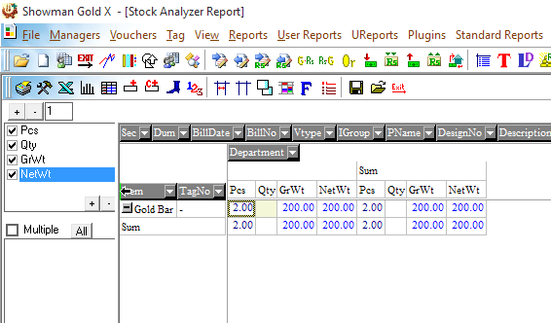
You can drag and drop any of the fields to show more details for eg you can drage the party name field and drop it in front of the Item Field to give stock from different parties

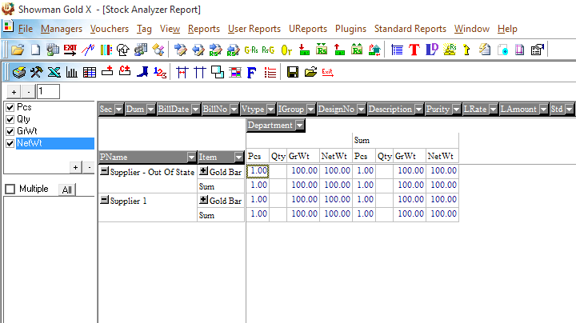
This will give the breakup by party
This means we have 100 gms from Supplier 1 and 100 gms from Supplier – Out of state

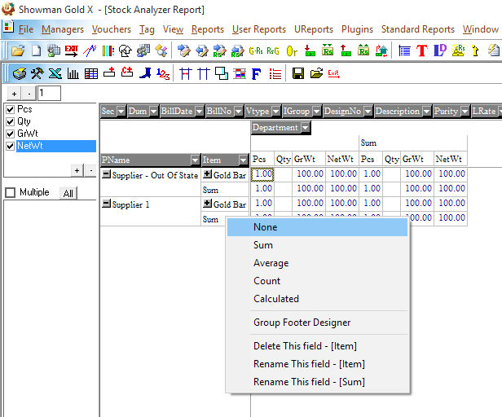
You can right click on any field value to bring up this menu.

For eg selecting None here will remove the Sum line which we have for each party

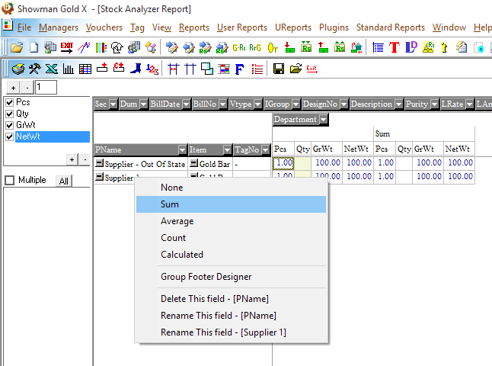
So we removed the Sum of each party

